*ISAD3000 Capstone Computing Project Milestone 3 Individual Report*

***Tanaka Chitete***

***Group E8: Amristar Industry Project [Virtual Jukebox application]***

Group Members:

Austin Bevacqua, Bradley van der Zwan, Dillon Vincent,   
Ryan Webster, Tanaka Chitete

## Curtin University – Department of Computing

## **Assignment Cover Sheet / Declaration of Originality**

## Complete this form if/as directed by your unit coordinator, lecturer or the assignment specification.

| Last name: | Chitete | Student ID: | 20169321 | |
| --- | --- | --- | --- | --- |
| Other name(s): | Tanaka | | | |
| Unit name: | Capstone Computing Project 1 | Unit ID: | ISAD3000 | |
| Lecturer / unit coordinator: | Senjian An | Tutor: |  | |
| Date of submission: | 15/04/2022 | Which assignment? | Milestone 3 | (Leave blank if the unit has only one assignment.) |

## I declare that:

## · The above information is complete and accurate.

## · The work I am submitting is *entirely my own*, except where clearly indicated otherwise and correctly referenced.

## · I have taken (and will continue to take) all reasonable steps to ensure my work is *not accessible* to any other students who may gain unfair advantage from it.

## · I have *not previously submitted* this work for any other unit, whether at Curtin University or elsewhere, or for prior attempts at this unit, except where clearly indicated otherwise.

## I understand that:

## · Plagiarism and collusion are dishonest, and unfair to all other students.

## · Detection of plagiarism and collusion may be done manually or by using tools (such as Turnitin).

## · If I plagiarise or collude, I risk failing the unit with a grade of ANN (“Result Annulled due to Academic Misconduct”), which will remain permanently on my academic record. I also risk termination from my course and other penalties.

## · Even with correct referencing, my submission will only be marked according to what I have done myself, specifically for this assessment. I cannot re-use the work of others, or my own previously submitted work, in order to fulfil the assessment requirements.

## · It is my responsibility to ensure that my submission is complete, correct and not corrupted.

| Signature: | TANAKA CHITETE | Date ofsignature: | 15/04/2022 |
| --- | --- | --- | --- |

## Progress Tracking

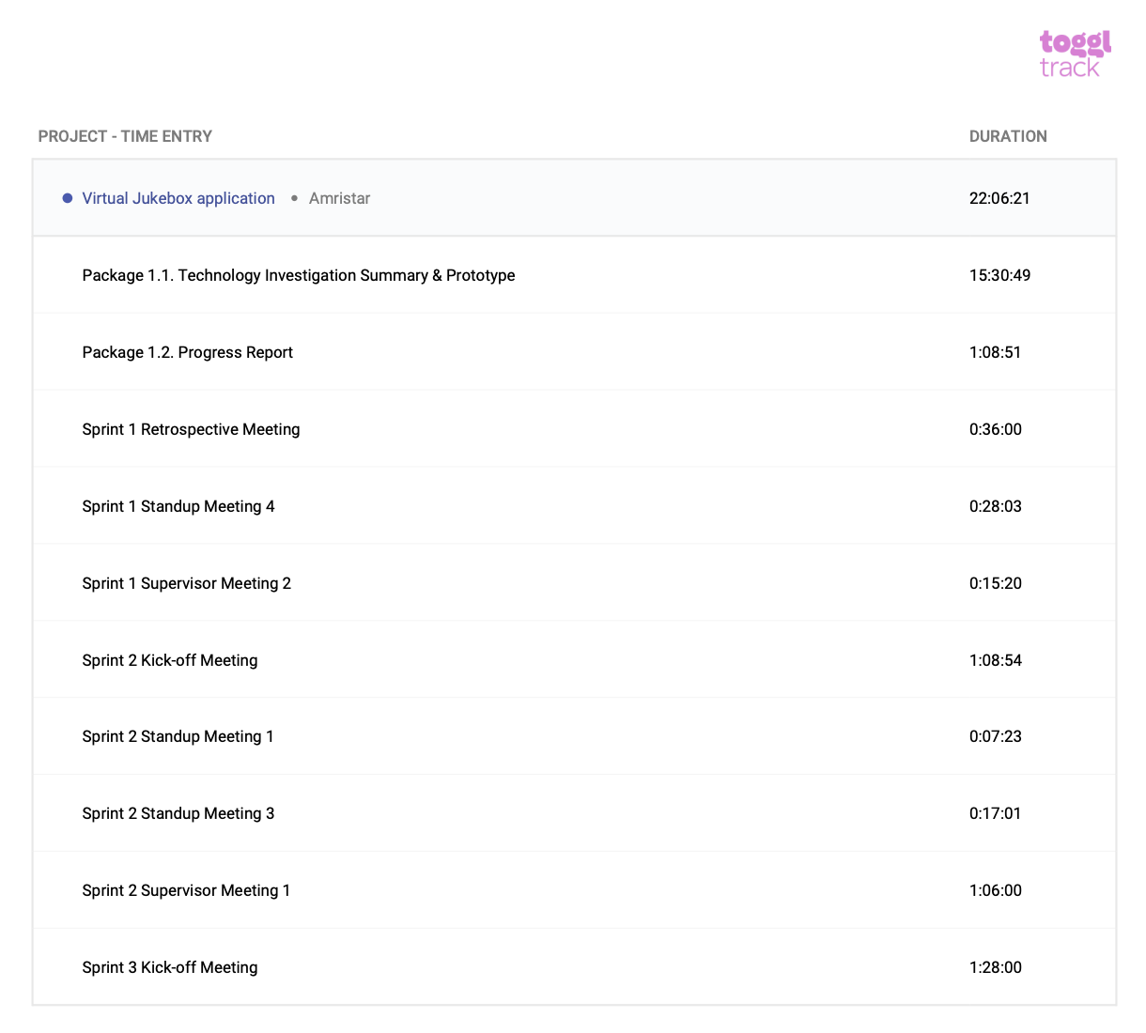

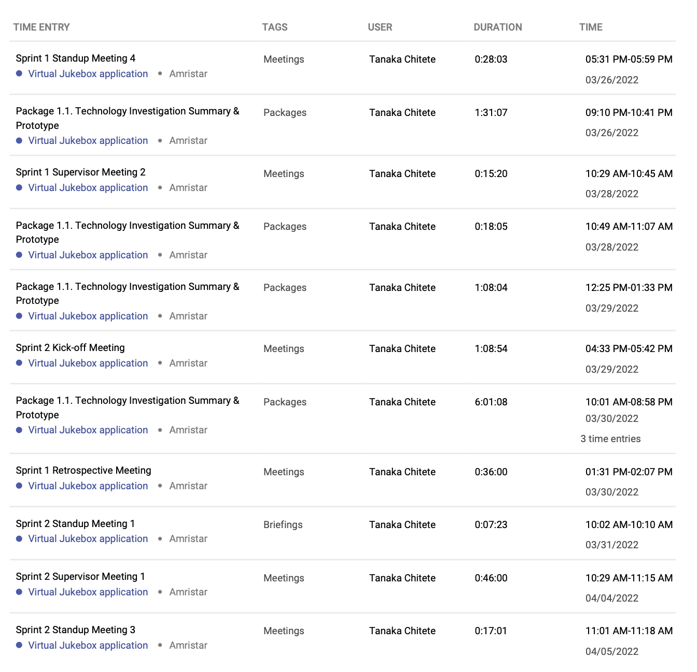

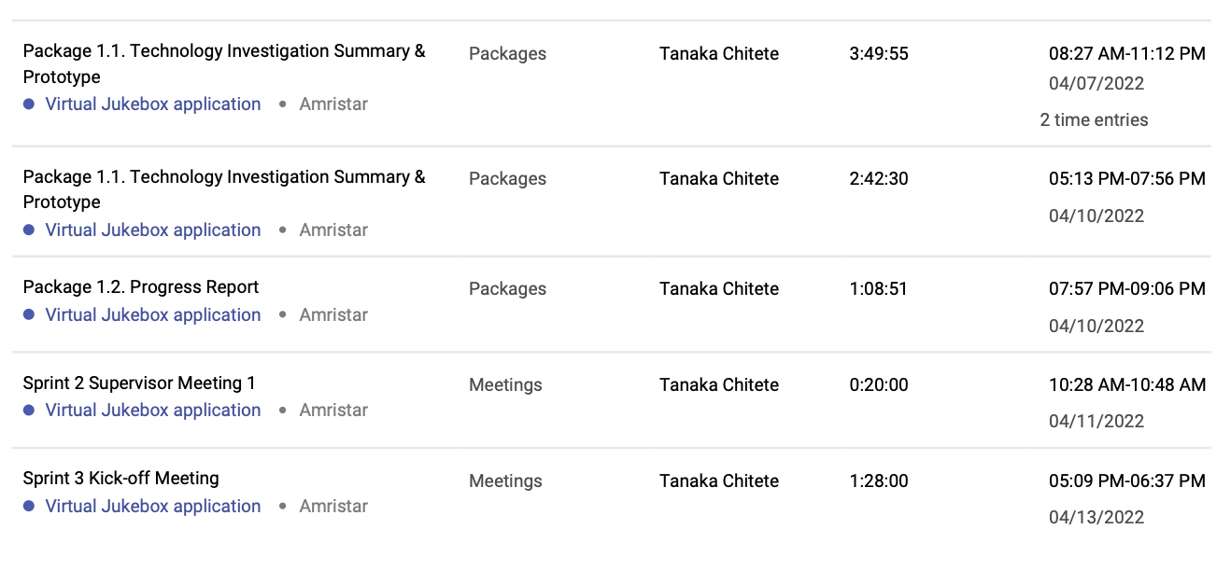

**Supervisor Meetings**

My presence is noted in each of these meetings via the Supervisor Meetings Minutes documents accessible via: <https://drive.google.com/drive/folders/1rKsgHWpck5Wpd935lpXTCyADSaPFoQgS?usp=sharing>

**Sprint Kick-off Meetings**

My presence is noted in each of these meetings via the Sprint Kick-off Meetings Minutes documents accessible via:

<https://drive.google.com/drive/folders/1OImhOwUw_PIgKJ7r6JA-oma24w2zfaJa?usp=sharing>

**Sprint Retrospective Meetings**

My presence is noted in each of these meetings via the Sprint Kick-off Meetings Minutes documents accessible via: <https://drive.google.com/drive/folders/1OImhOwUw_PIgKJ7r6JA-oma24w2zfaJa?usp=sharing>

**Standup Meetings**

My presence is noted in each of these meetings via the Sprint Kick-off Meetings Minutes documents accessible via: <https://drive.google.com/drive/folders/1OImhOwUw_PIgKJ7r6JA-oma24w2zfaJa?usp=sharing>

**Package 1.1. Technology Investigation Summary & Prototype**

After the sprint kickoff, I was assigned to do research into frontend and backend frameworks for the technology investigation. All my work was done on the cloud on Google slides, so all times I edited the document are visible.

After the Sprint Kickoff Meeting, I was assigned to research music streaming SDKs for the Technology Investigation Summary. All of the work I did was collated into the final document. The document can be accessed here:

[Technology_Investigation_Summary_(v1.0).docx](https://docs.google.com/document/d/1hnBtiuO2KsugEbwM52fdL8kvcNOyucH-/edit?usp=sharing&ouid=103418368896173571245&rtpof=true&sd=true)

**Milestone 3. Technology Investigation Summary**

This document and Milestone 3. Technology Investigation Summary (Group) outline the work done by myself and the group over the period 26/03/2022–15/04/2022.

## Summary

I am on track to complete all of my tasks for this sprint. The Technology Investigation done on the streaming SDKs went quite smoothly. Given that the frontend chosen, Vue and the streaming SDK chosen, Spotify, are both JavaScript based, integration should go along quite without any major difficulty. We are communicating regularly via Discord and Google Meet and we have already assigned work to be completed for the newly-begun sprint and we are already in the process of constructing the SRS.